**Send DICOM Data from RayStation to Another Facility**

**Purpose:** This procedure describes CRMC’s standard practice for sending RayStation DICOM files to another facility.We prefer to use an FTP link provided by the facility, but this procedure also explains how to send via DVD.

1. Export DICOM data from RayStation.
   1. Create a new folder called *<patient last name>, <patient first name CRMC DICOM* in *T:\Physics - T\Temp*. Create a new folder for each plan that you will export. Name each folder *<plan name> <planning exam date>*.

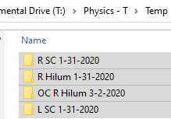

* 1. Export each plan from RayStation to a File: the folder created in the last step. Export the planning exam, the approved structure set, the plan, and the plan dose. These should be checked by default, but remember to uncheck the beam dose. (Beam dose is only used by RayStation, which we can’t be certain the other facility uses.)

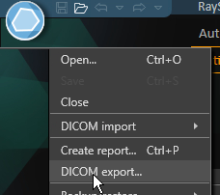

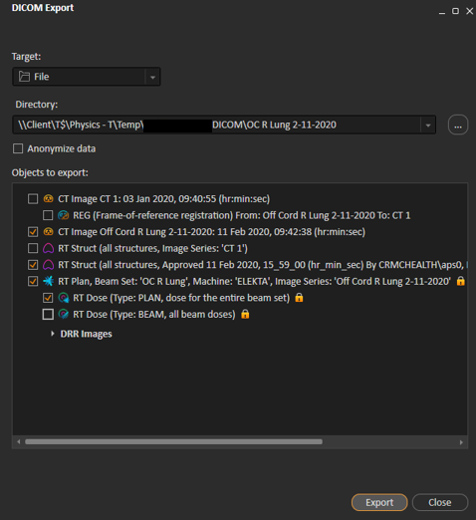

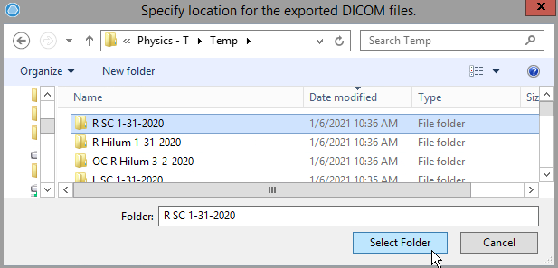

1. Zip the patient folder.
2. Send the zip file to the other facility. If you are not sending via DVD, skip steps 4 and 5 and simply upload the zip file to the link that the other facility sends you.
3. Put DICOM files on DVD.
   1. Obtain a blank DVD from the hallway cabinet closest to dosimetry.
   2. Insert the DVD into the DVD drive at the MIM computer (this is the only computer that we know can format DVDs).
   3. Follow the prompts to format the DVD as a USB drive. Title the disc *RT DICOM files*.
   4. Drag and drop the DICOM folders to the DVD.
   5. Eject the DVD from the drive.
4. Mail DVD.
   1. Use a Sharpie to write the following on the DVD: patient name, patient DOB, *RT DICOM files*.
   2. Put the DVD in a DVD envelope (also in the hallway cabinet).
   3. Write down the address and FedEx account number if applicable and take envelope to Amy York in the front office.